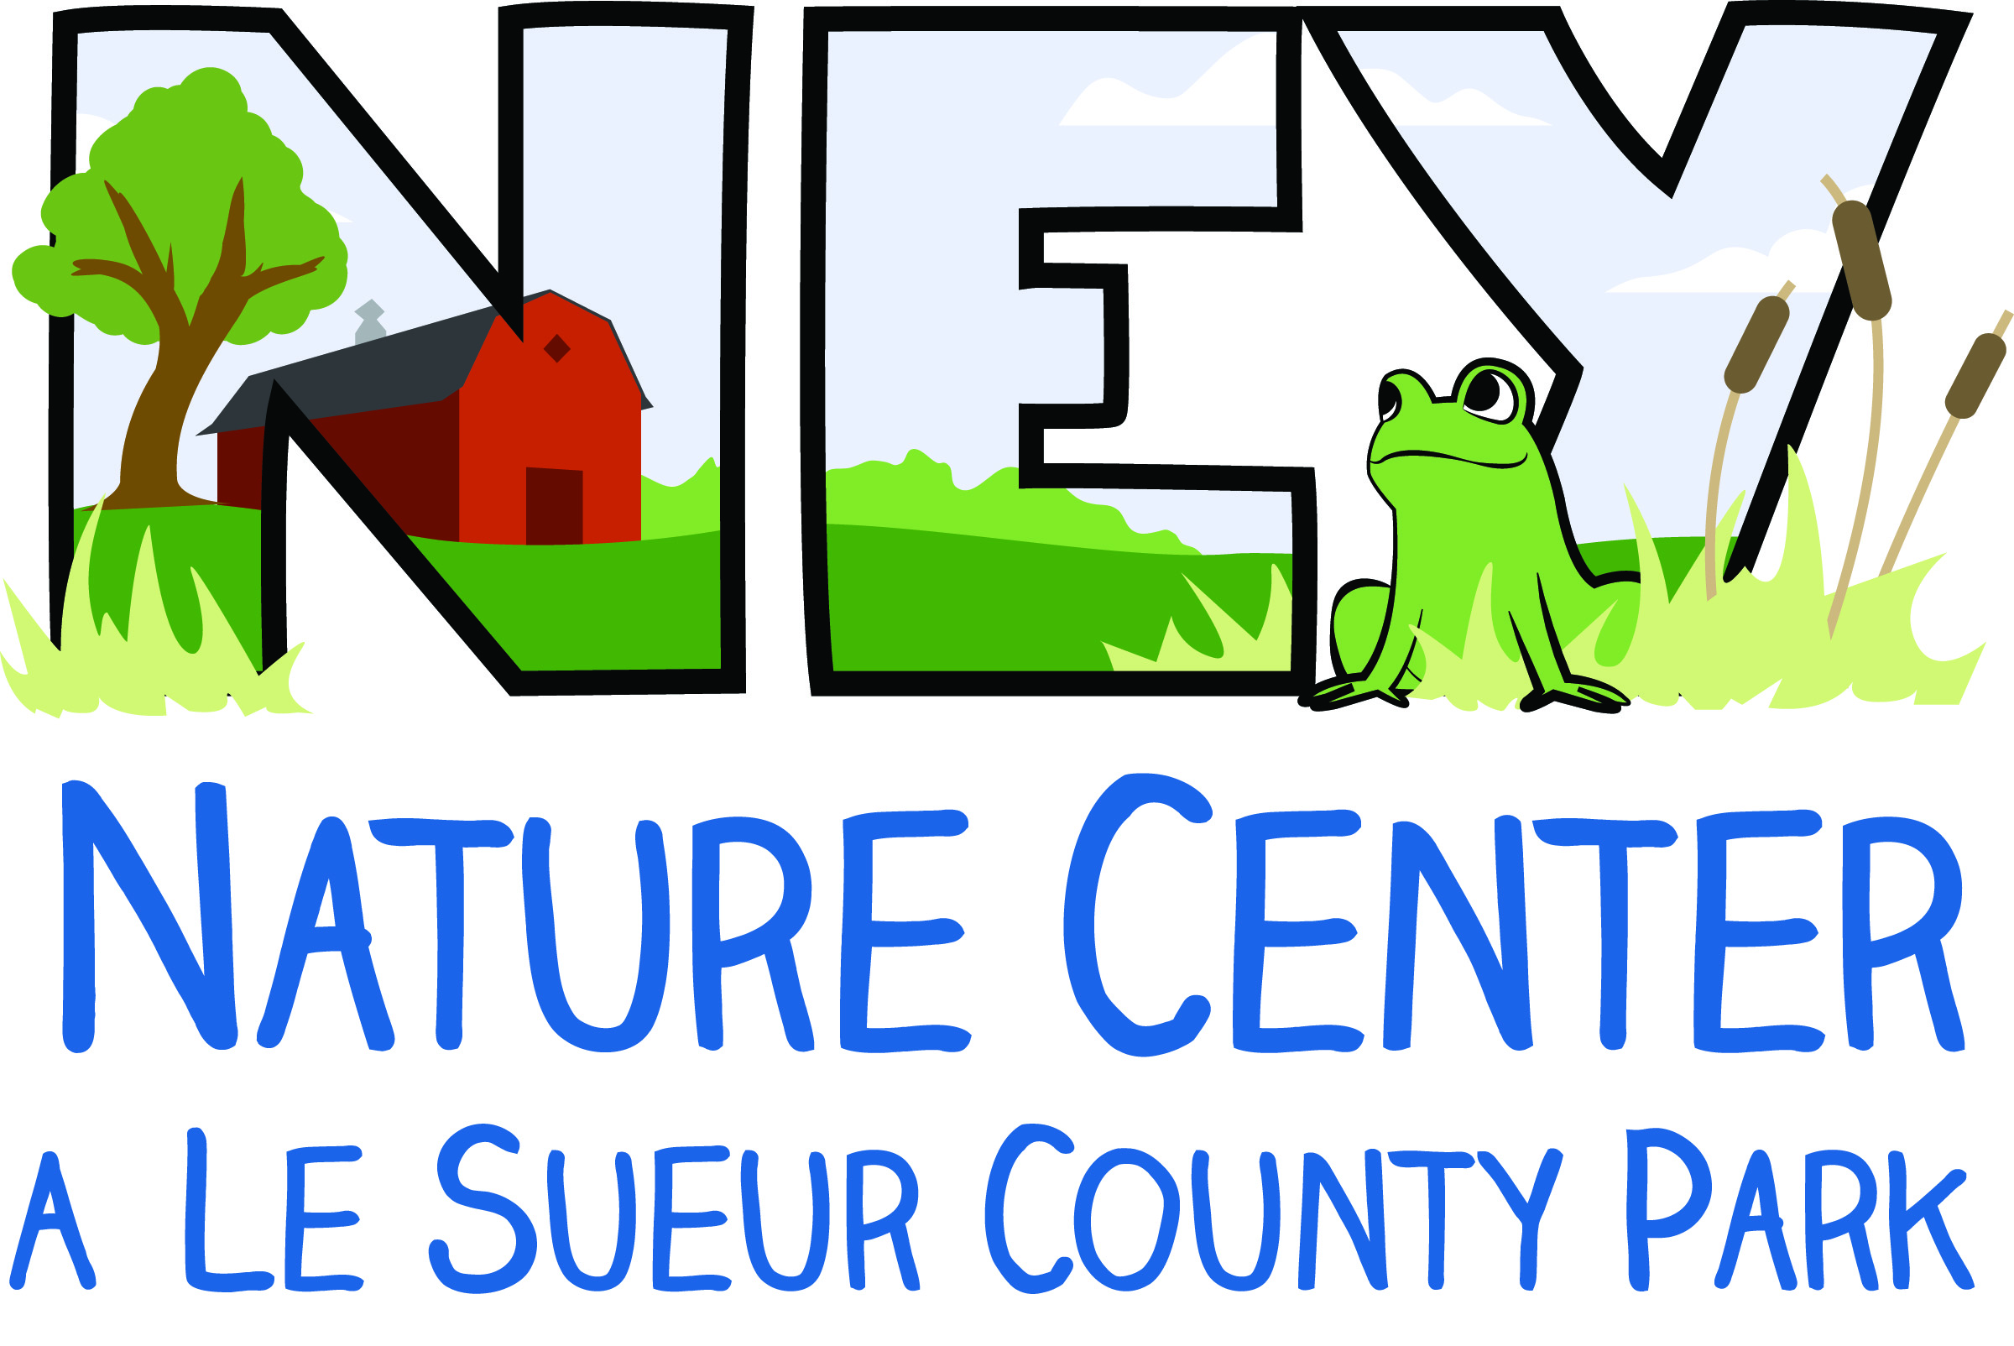
Camper Registration Form
Ney Nature Center’s Summer Day Camp

Camper Information – Please Print
Camper’s Name (First, MI, Last) __________________________________________________________________________

Address _____________________________________________________________________________________________________

Phone _______________________________________________________________________________________________________

E-mail Address _____________________________________________________________________________________________

Grade in Coming Fall _____________ Bluebird (completed K-2) ________ Eagle (completed 3-5) ________

Family Member of the Ney Nature Center _______________ Yes _______________ No

*Become a member at the $25 Family level to receive member discounts on camp fees. For more information on membership visit www.neycenter.org or contact Michelle 507-248-3474/ michellei@neycenter.org

Session Attending. Check all that apply:
Session 1 ___________ Session 2 ____________ Session 3 _____________

COMPLETE HEALTH/AUTHORIZATION FORM ON REVERSE SIDE

Fee is due at time of registration. Make checks payable to ‘Ney Nature Center’

Please sign and mail completed forms with check to:
Ney Nature Center
PO Box 93
Henderson, MN 56044

Office Use Only

Payment Information
Date Received ____________________________

Day Camp Fee Due ____________________________

Amount Paid ____________________________

Check # ____________________________
Camper Health Form/ Authorization
Ney Nature Center’s Summer Day Camp

Camper’s Name (First, MI, Last) __________________________________________________________________________
Session(s) Attending: Session 1 _______ Session 2 _________ Session 3 _________

Parent/Guardian Information (Please Print)
In the care of: Both Parents ________ Mother Only ___________ Father Only ___________ Other ___________
Name of Custodial Parent(s)/Guardians(s) ______________________________________________________________
Phone: Day _________________________ Evening ____________________________ Cell _____________________________

Person to contact in case of an emergency if parent/guardian cannot be reached
Name _______________________________________________ Relationship _________________________________________
Day Phone _______________________________________Cell Phone _______________________________________________

Medical Contact Information
Physician’s Name ___________________________________________ Phone _______________________________________
Medical Insurance Carrier _____________________________________Policy ____________________________________

Heath Considerations of Camper
Vaccinations required by school up-to-date? Yes ______ No ____ (If no, please send an explanation note)
Allergies (Include medication and other) Reaction and Treatment
________________________________________________ _______________________________________________________
________________________________________________ _______________________________________________________

Chronic Concerns
________ This camper has no chronic health concerns and is capable of full participation.
________ This camper has the following chronic health concern(s). Check all that apply.
__________ Asthma _________ Diabetes ___________ Headaches
__________ Epilepsy _________ Other(s) ___________________________________________________
Provide information about supportive health care needs for each checked item
_______________________________________________________________________________________________________________
Please explain if your camper has had a history of illness, injury, or surgery, which will affect participation ________________________________________________________________________________________________
_______________________________________________________________________________________________________________

Parent/Guardian Authorization
I give permission for my camper to attend NNC’s Day Camp and participate in all activities. I give permission to be photographed and for the Ney Nature Center to use the picture for publicity.

The Emergency Care Information about my camper is complete and accurate. I know of no reason, other than as indicated, why my child should not participate in prescribed activities. In the event my child needs medical attention while at Day Camp, I authorize the adult in charge to see that my child receives reasonable first aid and to transport my child to a health care facility for emergency services as needed.

Signature of Parent/Guardian ___________________________________________________ Date ___________________

