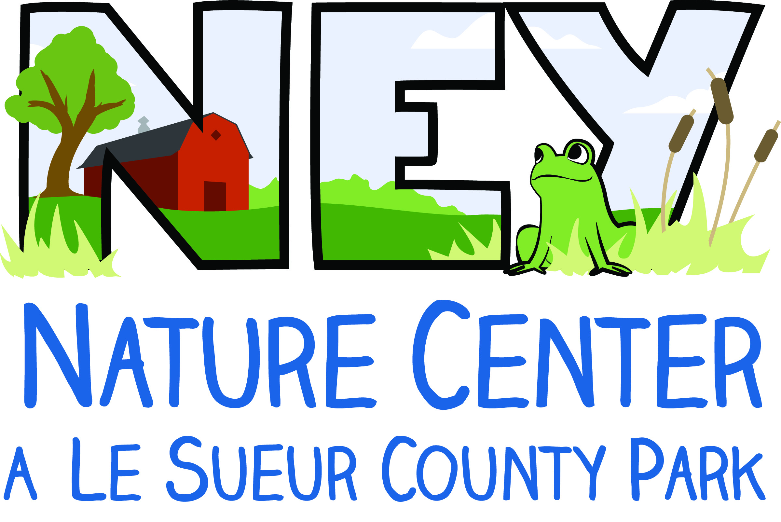
Camper Registration Form
Ney Nature Center’s Winter Day Camp

Camper Information – Please Print
Camper’s Name (First, MI, Last) __________________________________________________________________________

Address _____________________________________________________________________________________________________

Phone _______________________________________________________________________________________________________

E-mail Address _____________________________________________________________________________________________

Grade in Coming Fall _____________

Family Member of the Ney Nature Center _______________ Yes _______________ No

*Become a member at the $25 Family level to receive member discounts on camp fees. For more information on membership visit www.neycenter.org or contact the office at 507-357-8580 or email info@neycenter.org.

Camp(s) Attending:
________________________________ _________________________________ _________________________________

COMPLETE HEALTH/AUTHORIZATION FORM ON REVERSE SIDE

Fee is due at time of registration. Make checks payable to ‘Ney Nature Center’

Please sign and mail completed forms with check to:
Ney Nature Center
PO Box 93
Henderson, MN 56044

Office Use Only

Payment Information
Date Received ____________________________

Day Camp Fee Due ____________________________

Amount Paid ____________________________

Check # ____________________________
Camper Health Form/ Authorization
Ney Nature Center’s Summer Day Camp

Camper’s Name (First, MI, Last) __________________________________________________________________________
Camp(s) Attending: ________________________________ _________________________________

Parent/Guardian Information (Please Print)
In the care of: Both Parents ________ Mother Only ___________ Father Only ___________ Other ___________
Name of Custodial Parent(s)/Guardians(s) ______________________________________________________________
Phone: Day _________________________ Evening ____________________________ Cell _____________________________

Person to contact in case of an emergency if parent/guardian cannot be reached
Name _______________________________________________ Relationship _________________________________________
Day Phone _______________________________________Cell Phone _______________________________________________

Medical Contact Information
Physician’s Name ___________________________________________ Phone _______________________________________
Medical Insurance Carrier _____________________________________Policy ____________________________________

Heath Considerations of Camper
Vaccinations required by school up-to-date? Yes ______ No ____ (If no, please send an explanation note)
Allergies (Include medication and other) Reaction and Treatment
________________________________________________ _______________________________________________________
________________________________________________ _______________________________________________________

Health Concerns
________ This camper has no health concerns that would limit camp participation.
________ This camper has the following health concern(s). Check all that apply.
__________ Asthma _________ Diabetes ___________ Headaches
__________ Epilepsy _________ Other(s) ___________________________________________________
Provide information about supportive health care needs for each checked item.
_______________________________________________________________________________________________________________
Please explain if your camper has had a history of illness, injury, or surgery.
_______________________________________________________________________________________________________________

Parent/Guardian Authorization
I give permission for my camper to attend Day Camp at the NNC and participate in all activities. I give permission for my camper to be photographed and for the Ney Nature Center to use any photos for publicity purposes.

The Emergency Care Information about my camper is complete and accurate. I know of no reason, other than as indicated, why my child should not participate in the prescribed activities. In the event my child needs medical attention while at Day Camp, I authorize the NNC staff to see that my child receives reasonable first aid and to transport my child to a health care facility for emergency services as needed.

Signature of Parent/Guardian ___________________________________________________ Date ___________________

