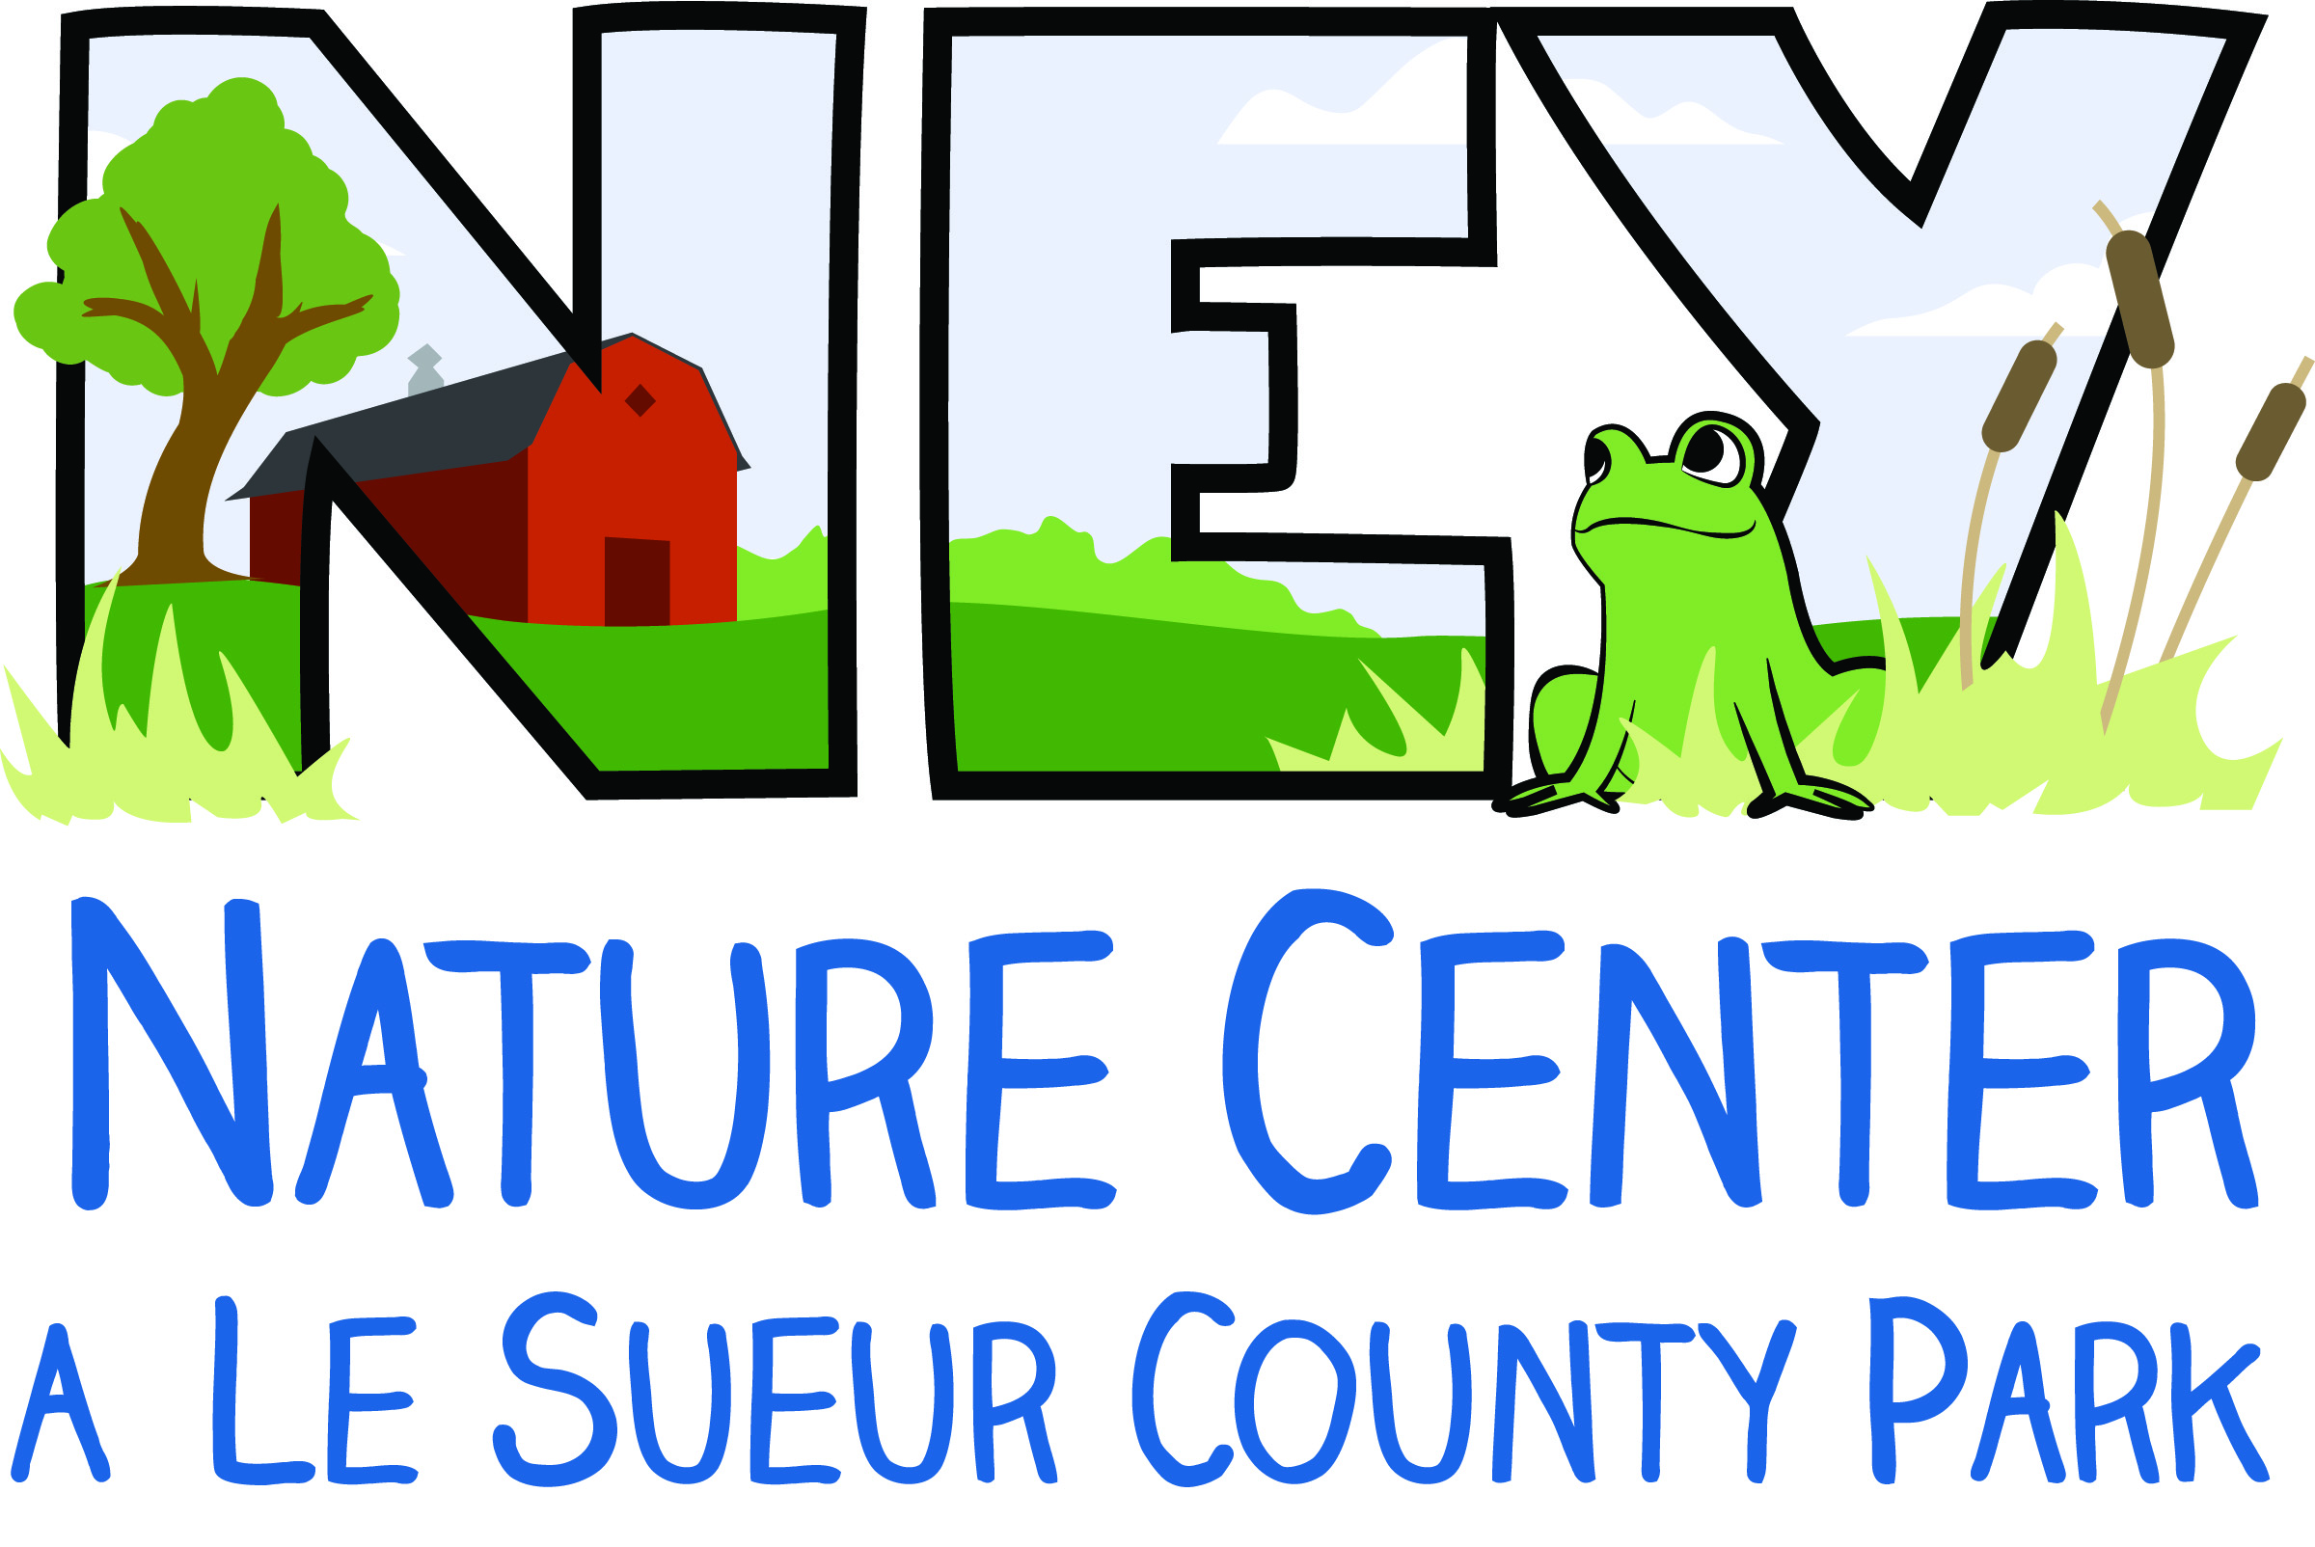
Ney Nature Center
Scholarship Application
Ney Nature Center provides need-based scholarships to families that qualify.

If you wish to apply for a scholarship, please send in:
1) This completed scholarship application
2) One of the following qualifying documents:
- A copy of the letter from your school district stating that you qualify for free or reduced lunches
- Proof (photo or scan) of enrollment in a Minnesota assistance programs such as:
  - EBT Card
  - eWIC Card
  - MHCP Card
- If you do not qualify through enrollment in an assistance program, you can still qualify if your income is less than 200% of the federal poverty guidelines. In this case we require your most recent tax return as proof of income.
- For children in foster care: The foster parent should attach the letter from the county that tells us the child is in your care instead of the tax return.

After you apply, if you qualify, you will be notified regarding the amount of your award. Scholarships do not cover the entire cost of programs. Filling out this application does not reserve your spot in any programs or camps. Program registration is only complete after space has been confirmed and Ney Nature Center receives the registration fees. Please email us or call 507-357-8580 for program availability information or if you have any questions.

Participant Information – Please Print
Name(s) of program participant(s): _______________________________________________________________________________________________________________

Program name: _____________________________________________________________________________________________

Parent/Guardian Name(s): ________________________________________________________________________________

Primary Phone: _________________________ Email: ________________________________________________________

Household size (include parents/guardians and children): ___________

Address: ____________________________________________________________________________________________________

City: ____________________________________________ State: _______ Zip Code: ______________

Signature of Parent/Guardian ___________________________________________________ Date ___________________

